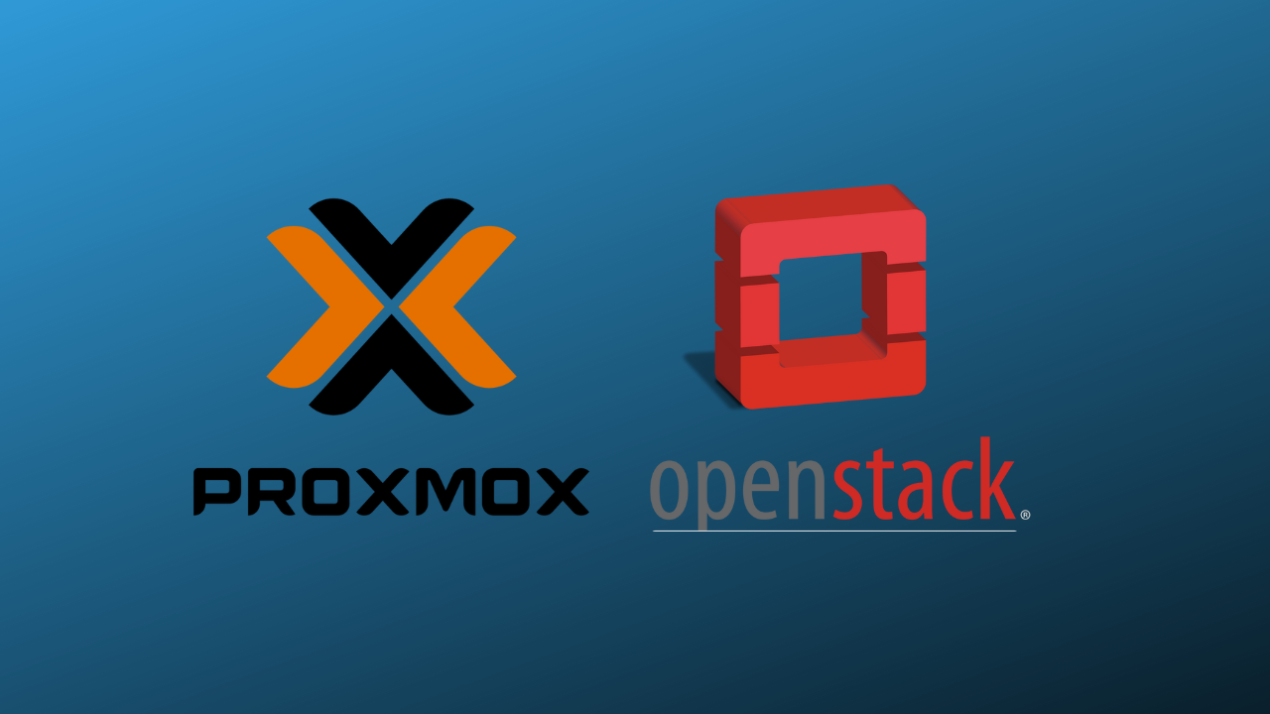

Project Team

Student Name Surname: MUBARAK BAN HUWAIL

Student No:20102019

Student Name Surname: ABDULRAHMAN ODHAIB

Student No:210201879

Student Name Surname: munasar abdi warsame

Student No:210208853

Student Name Surname: Zakaria Isak Ali

Student No:210201964

Student Name Surname: Yahye Said Abdi

Student No:210201922

Project Consultant:

Dr. Öğr. Üyesi METİN BALCI

Introduction to Proxmox
Proxmox Virtual Environment (VE) is a powerful open-source platform for managing virtual machines (VMs) and containers. It combines Kernel-based Virtual Machine (KVM) for full virtualization and Linux Containers (LXC) for lightweight virtualization, providing flexibility for small and enterprise-level environments. Built on Debian Linux, Proxmox VE simplifies virtual infrastructure management through a user-friendly web interface and robust features.
Key highlights include:
- Centralized Management: Supports clustering and real-time configuration replication via Proxmox Cluster File System (pmxcfs).
- Flexible Storage: Offers local and shared storage options, storage pools, and live VM migration.
- Integrated Backup and Restore: Enables scheduled backups, flexible storage options, and seamless recovery processes.
- High Availability (HA): Automates failover with an HA Manager and supports resource prioritization for clusters.
- Networking Capabilities: Provides bridged networking, VLANs, network bonding, and integrated firewalls for security and performance.
- Open-Source Benefits: Transparency, community contributions, and no vendor lock-in enhance flexibility and trust.
With features like role-based access control, two-factor authentication, hyper-converged infrastructure support, and comprehensive documentation, Proxmox VE empowers organizations to efficiently manage virtual environments.

Understand the Objectives of Virtualization Project

Goal
The primary goal of this project is to explore and analyze virtualization technologies, specifically Proxmox and VMware, to gain a comprehensive understanding of their mechanisms and functionalities. By delving into these platforms, we aim to identify their strengths, weaknesses, and unique features that contribute to their effectiveness in managing virtualized environments.

Implementation
To achieve this goal, the project will focus on investigating how the virtualization capabilities observed in Proxmox and VMware can be integrated into OpenStack. This will involve:
- Assessing the architectural components and operational workflows of Proxmox and VMware.
- Identifying key features such as resource allocation, management interfaces, and orchestration tools that can enhance OpenStack's existing capabilities.
- Exploring potential integration strategies, including the development of plugins, APIs, or extensions that allow OpenStack to leverage similar virtualization functionalities.

Deliverable
The culmination of this project will be a comprehensive technical report that details the findings from our research and analysis. This report will include:
- A comparative analysis of Proxmox, VMware, and OpenStack, highlighting their respective architectures, tools, and mechanisms.
- Insights into the strengths and limitations of each platform, providing a clear understanding of their operational efficiencies.
- Recommendations for integrating the identified virtualization capabilities into OpenStack, along with potential implementation strategies and considerations.
This technical report will serve as a valuable resource for stakeholders interested in enhancing OpenStack's virtualization capabilities and will contribute to the broader understanding of cloud infrastructure solutions.

Introduction
In the ever-evolving digital landscape, virtualization has become a cornerstone of modern cloud computing, enabling efficient resource utilization and scalable infrastructures. By abstracting physical hardware, virtualization allows multiple virtual machines to operate on a single server, enhancing flexibility, cost-effectiveness, and operational efficiency. This foundational technology powers cloud computing, allowing organizations to dynamically manage and deploy resources.
OpenStack stands as a prominent cloud infrastructure platform, providing a comprehensive suite of services for building and managing public and private clouds. Its robust framework supports the deployment of virtualized resources, making it a favored choice for organizations aiming to leverage cloud computing effectively.
This project aims to bridge functionalities across virtualization platforms, focusing on the following objectives:
- Analyzing and understanding the capabilities of Proxmox and VMware, two leading virtualization solutions.
- Investigating their operational mechanisms to gain deeper insights.
- Integrating similar functionalities, such as snapshot management, into OpenStack to enhance its feature set and usability, offering a more versatile cloud infrastructure solution.

Enhancing Virtualization in OpenStack: Leveraging Flask and Proxmox Snapshots
In this report, we aim to explore a unique approach to implementing virtualization within OpenStack by integrating tools and techniques that go beyond traditional methods. Specifically, we will delve into the role of Flask, a lightweight web framework, and how it aids in achieving this objective. Flask serves as a key component, enabling the simulation of API functionalities essential for testing and development in a controlled environment.

Additionally, we will analyze the Proxmox snapshot feature and its potential to further enhance the virtualization process. Snapshots are a critical component of virtualization, offering the ability to capture and restore the state of virtual machines efficiently. By incorporating similar functionalities into OpenStack, we aim to demonstrate how Proxmox’s innovative features can improve OpenStack’s overall virtualization capabilities.

Finally, this report will showcase the integration of these technologies and methodologies, providing a comprehensive understanding of how OpenStack can be enhanced to deliver advanced virtualization features. Through this exploration, we will highlight the synergies between Flask, Proxmox, and OpenStack, illustrating how they contribute to creating a more flexible, robust, and user-friendly virtualization environment.

Methodology

Tools and Technologies
- Operating System: Ubuntu (in VMware virtualization).
- OpenStack Version: DevStack.
- Programming Language: Python 3.
- Web Framework: Flask.
- Proxmox Feature: Snapshots.

Prerequisites
- OpenStack installed and configured using DevStack.
- Python 3 installed.
- Virtual environment for Python setup.

Step-by-Step Implementation

Step 1: Create a Virtual Environment
To set up a virtual environment, use the following commands:
python3 -m venv venv
source venv/bin/activate
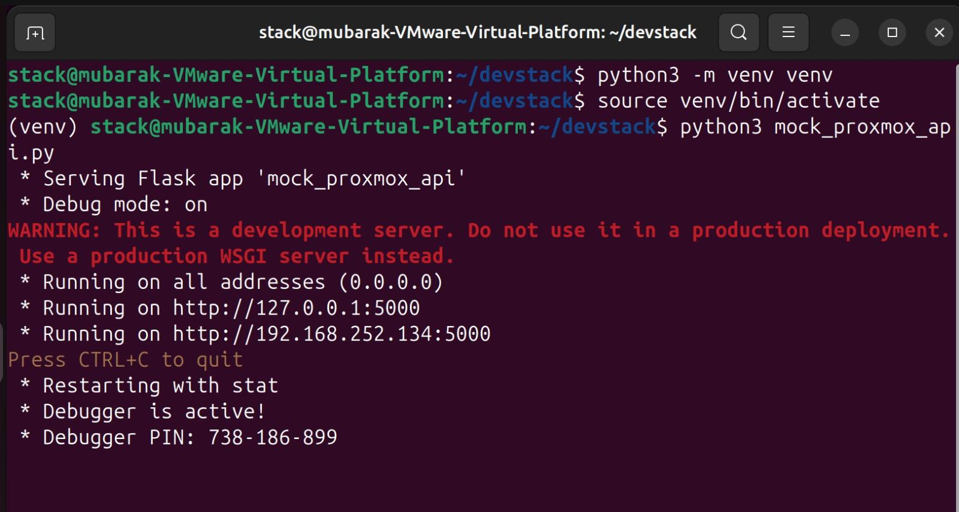
Step 2: Install Flask

For full documentation on User’s Guide
Welcome to Flask — Flask Documentation (3.1.x)

Once your virtual environment is activated, install Flask using pip:
pip install flask

Notes:
- Always ensure your virtual environment is activated before installing dependencies.
- To deactivate the environment, use the command
deactivate

Create the Flask Mock API

Step 1: Create the mock_proxmox_api.py File
Write the following Flask application to mock API endpoints for snapshot creation and listing:
nano mock_proxmox_api.py
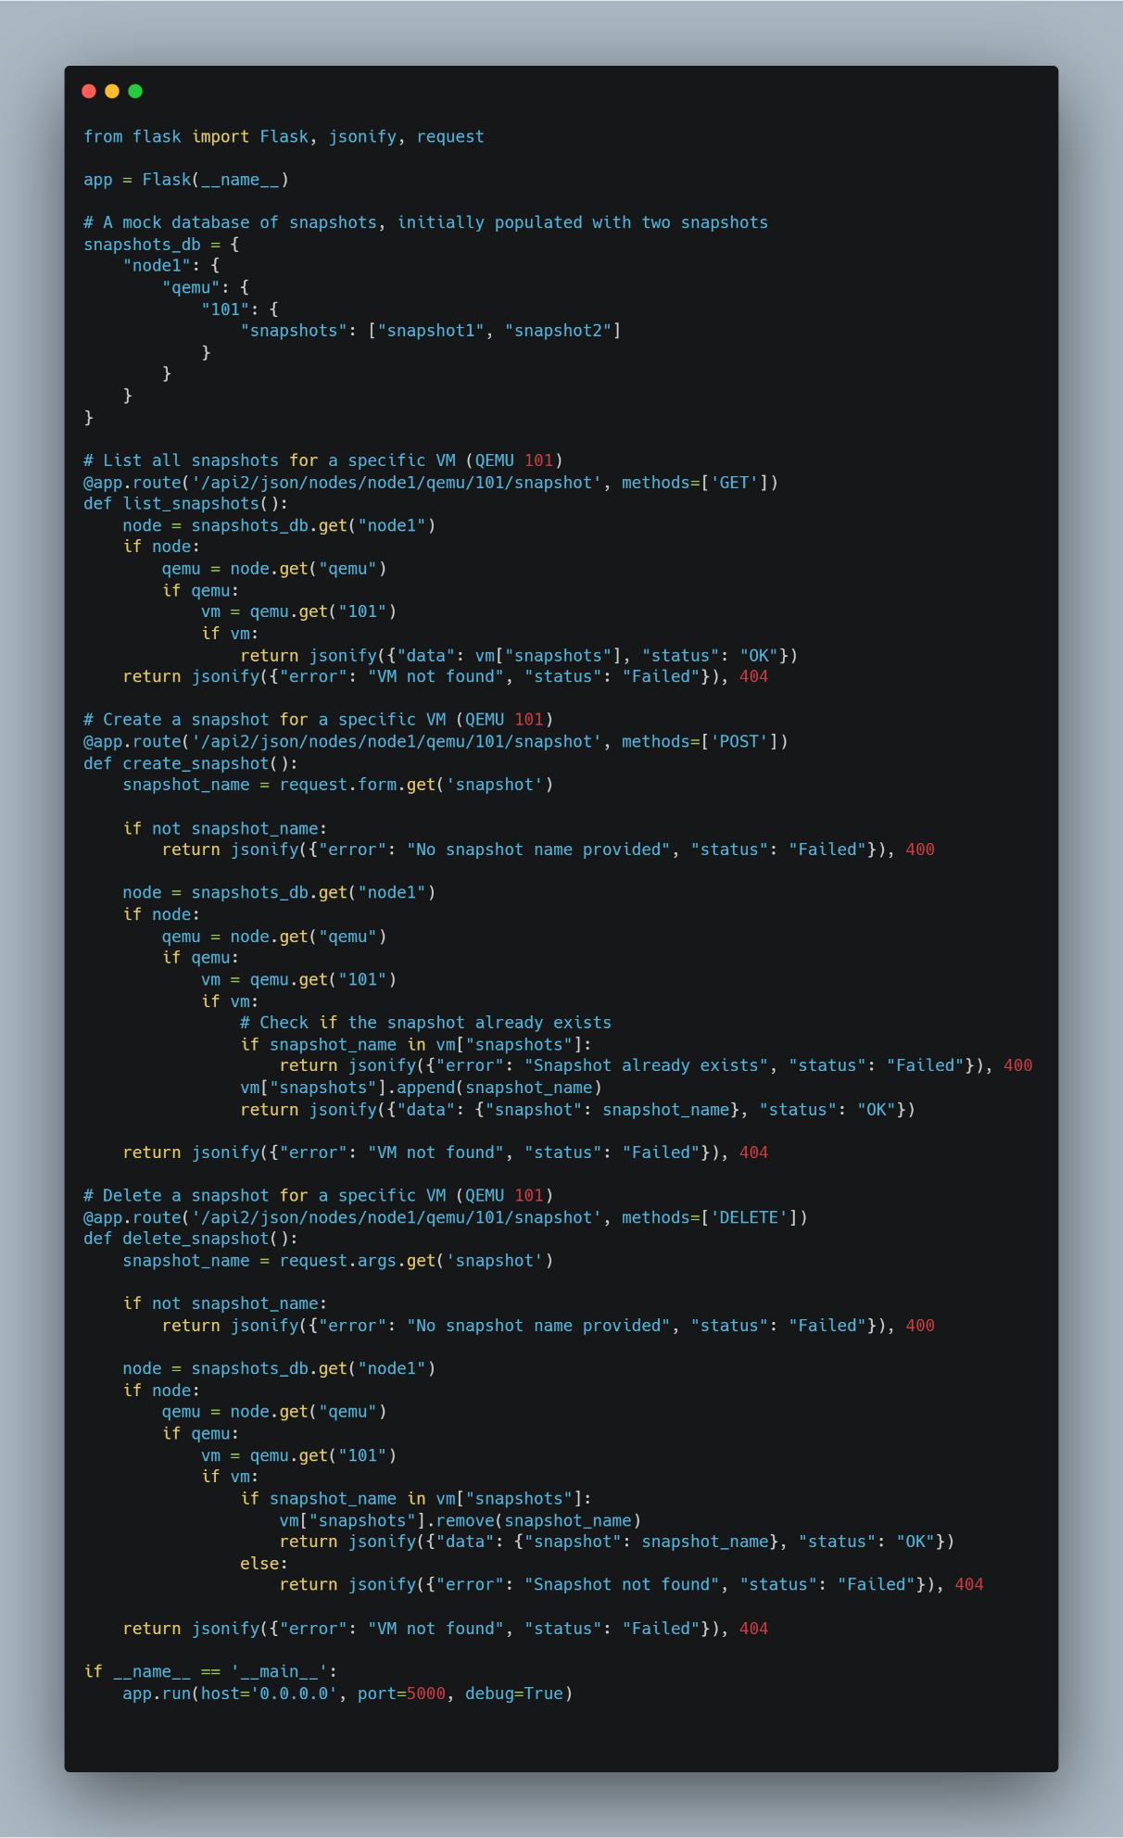

Note: The code will be provided with the Report.

Step 2: Run the Flask App
Start the Flask application by running the following command in your terminal:
python3 mock_proxmox_api.py

Output
- The Flask app will run on the following addresses:
  - Localhost: http://127.0.0.1:5000
  - Network: http://192.168.252.134:5000
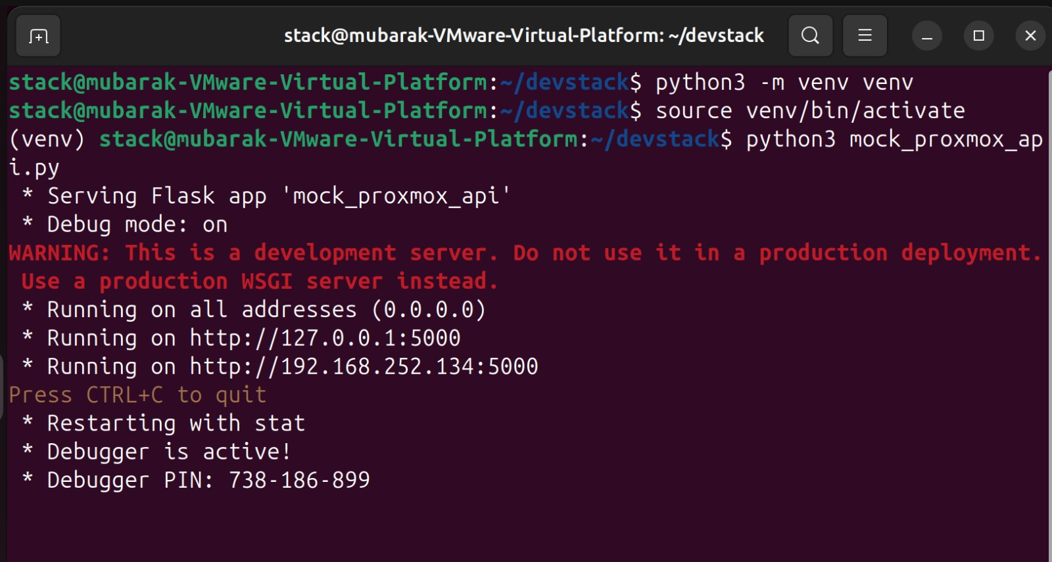

Highlights Flask's role in stimulating Proxmox's API, testing snapshot functionality, and providing a controlled environment for OpenStack integration. It is well-structured, detailed, and includes practical examples of Flask endpoints, showcasing its importance in testing and debugging. Excellent clarity and technical depth make the explanation valuable for understanding the project's setup.
Role of Flask in the Project
In the project, which involves integrating a Proxmox-like snapshot mechanism into OpenStack, Flask plays a crucial role as a lightweight web framework. Here’s how it contributes:

Simulating Proxmox API Functionality: Flask is used to mock the behavior of the Proxmox API. Since the project focuses on replicating Proxmox’s snapshot functionality in OpenStack, Flask provides a simulated environment where snapshot management features can be tested without needing access to an actual Proxmox environment. This allows for simulating key operations like creating, managing, and restoring snapshots.

Testing Snapshot Integration: Flask acts as a mock API server, allowing OpenStack to interact with it and test how snapshot management might function in an integrated system. By simulating Proxmox-like behavior, Flask helps demonstrate how OpenStack could interact with a similar API for snapshot management, even without Proxmox being part of the test environment.

Providing a Controlled Environment: By mocking Proxmox API calls through Flask, a controlled environment for testing OpenStack’s interaction with snapshot-related features is created. This isolation ensures that OpenStack can be tested for snapshot functionality without depending on a real Proxmox server, making it easier to debug and iterate.

Development Server: Flask runs on a development server (e.g., http://127.0.0.1:5000 or http://192.168.252.134:5000), which hosts the mock API endpoints. OpenStack components can make HTTP requests to these endpoints to perform snapshot-related actions. These requests simulate what would happen if OpenStack were interacting with a live Proxmox system, enabling testing and development.

How Flask Works in the Project
Mock Endpoints: The mock_proxmox_api.py script defines various Flask routes (endpoints) that simulate Proxmox’s API calls for snapshot management. Example endpoints could include:

POST /snapshots: For creating a snapshot of a virtual machine.
GET /snapshots/{snapshot_id}: For retrieving details of a specific snapshot.
DELETE /snapshots/{snapshot_id}: For deleting a snapshot by its ID.
These routes simulate the expected behavior of Proxmox’s API, making it easier to test the integration without using the actual Proxmox server.

Interaction with OpenStack: OpenStack components (such as Nova or Cinder) can send requests to the Flask API when performing snapshot management tasks. For instance, Nova might request to create a snapshot of a virtual machine, and it would interact with the mock Proxmox API through the Flask server. The responses from Flask provide feedback on whether the requested snapshot operations were successful, allowing OpenStack to handle these operations as if it were interacting with a live Proxmox server.

Debugging and Logs: Flask includes built-in debugging features that are useful during development. If there are issues with the mock API or its integration with OpenStack, Flask's debug mode provides detailed error logs and information. This helps identify any issues early in the development process and allows troubleshooting of the behavior of the simulated Proxmox API quickly.

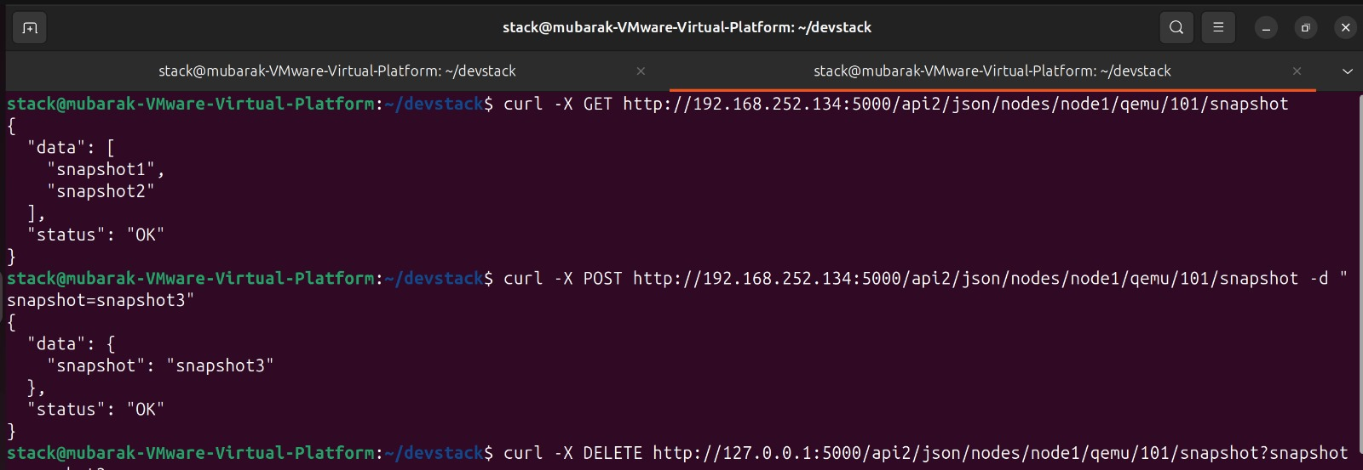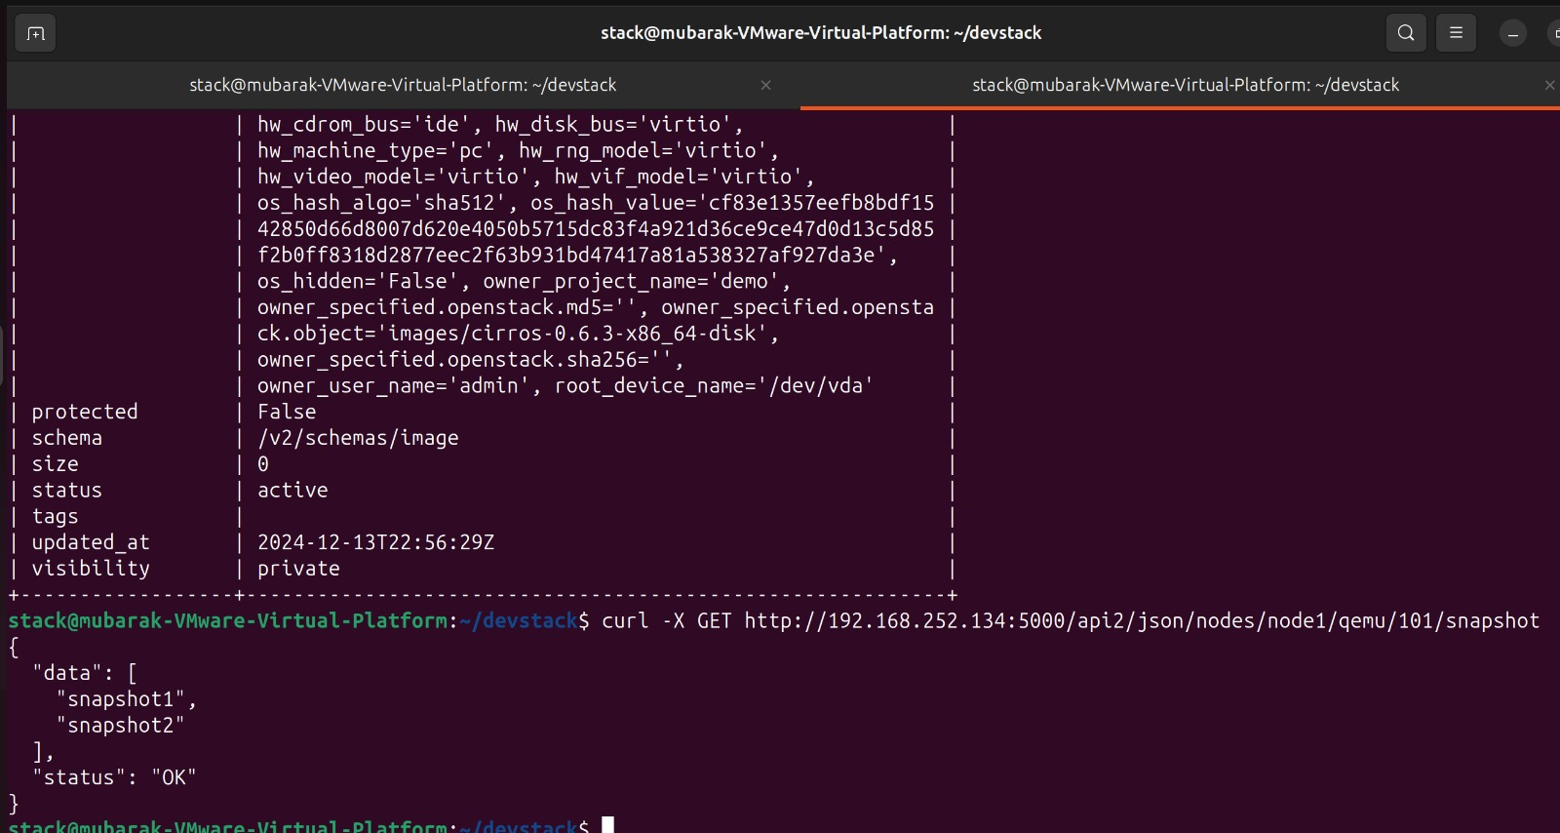

OpenStack Instance Tab
- Snapshot Creation
- Navigate to the Instance Tab in OpenStack's dashboard.
- You should see the list of available virtual machine instances.
- Select the desired instance for which you want to manage snapshots.
- The mock API allows you to simulate creating a snapshot by providing a snapshot name.
- When the snapshot is created successfully, OpenStack will display the snapshot under the instance's "Snapshots" section.
- Snapshot List
- The mock API fetches a list of pre-defined snapshots.
- These snapshots are displayed in the UI, mimicking the real functionality of snapshot management in OpenStack.
- The snapshot list includes placeholder snapshots, such as snapshot1 and snapshot2.

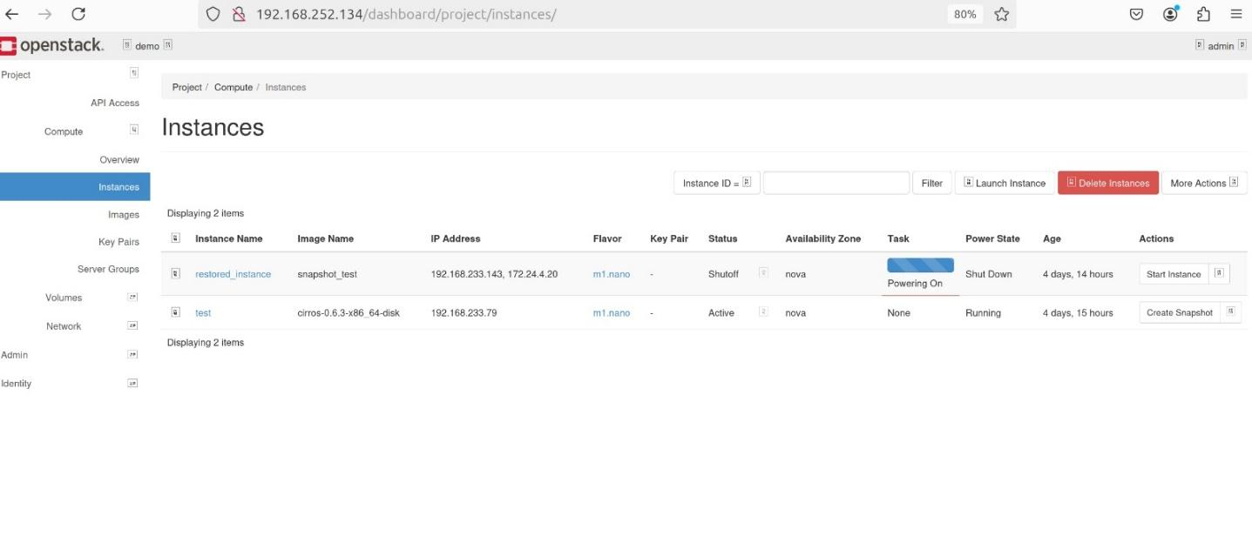

Home Page
- Overview
  - The Home Page of the OpenStack dashboard provides an overview of your cloud resources.
  - After integrating the mock API, the dashboard reflects basic snapshot functionality under the instances section.
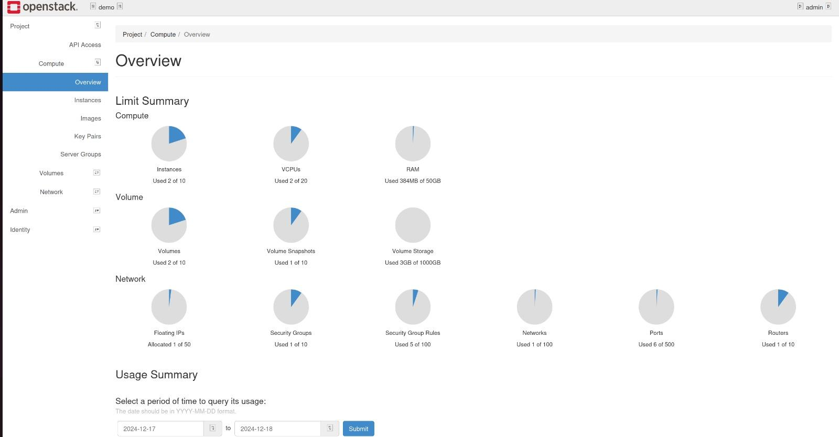

Analysis and Comparison
- Compare the following aspects for Proxmox, VMware, and OpenStack:
  - Hypervisor: Features, efficiency, scalability.
  - Management: Tools and interfaces (e.g., Proxmox VE, vSphere).
  - Networking: Virtual switches, overlays.
  - Storage: Integration, shared storage, and volumes.
- Summarize findings in a comparative table.

Results and Challenges

Implementation Progress

The project successfully implemented a mock Proxmox API using Flask to simulate snapshot creation and listing.

Integration testing with OpenStack was performed by utilizing the DevStack environment on Ubuntu.

The API endpoints provided functionalities to mimic snapshot management, which were reflected in the OpenStack dashboard under the Instance Tab and the Home Page.

Challenges Faced

API Compatibility: Adapting the Proxmox API features to align with OpenStack’s architecture required significant adjustments.

Networking Issues: Ensuring connectivity between the Flask application and the OpenStack platform posed intermittent challenges.

Snapshot Simulation: Limited functionality of the mock API constrained its ability to replicate advanced Proxmox snapshot features comprehensively.

Conclusion and Recommendations

Key Findings
- OpenStack's flexibility allows seamless integration of external virtualization functionalities through APIs.
- Mocking Proxmox's snapshot capabilities demonstrated the feasibility of enhancing OpenStack with additional features.
- The comparative analysis underscored the strengths of Proxmox, VMware, and OpenStack in different aspects, such as hypervisor efficiency, management tools, and storage integration.

References:
Proxmox VE Documentation Index
https://youtu.be/8DCwnauqg3E?si=9C5JWgd5N0aVZhuW
https://youtu.be/zsYIw6RXjfM?si=JG_TSEGqaeB5DMnG
Welcome to Flask — Flask Documentation (3.1.x)

